
BANK CUSTOMER DATA ANALYSIS
POWER BI DASHBOARD REPORT

Prepared By: S.Pranesh
Class: B.Com banking & Insurance
Roll no: 24BBI034
Date: 08/12/2025
Course: Power BI
Project Title: Bank Customers Data Analysis

Bank Customers Data Analysis – Dashboard Report
Introduction
This report provides a detailed explanation of the Power BI dashboards created for analyzing bank customer data. Each dashboard focuses on different aspects such as customer demographics, financial behavior, credit and loan details, and customer segmentation. The report explains each visual in simple and clear sentences.

1. CUSTOMER OVERVIEW DASHBOARD
This dashboard gives a simple summary of all the bank customers. It shows the basic characteristics like age, gender, location, education, and marital status.
• Total Customers: 10,000
• Male Customers: 5,457
• Female Customers: 4,543
• Average Age: 38.92 years
Customer Distribution:
• Customers by Geography: Highest in Spain, followed by Germany and France.
• Customers by Marital Status: Categorized as married, single, and unmarried.
• Customers by Gender: Shows male and female percentages.
• Customers by Education: Most customers are graduates.
• Customers by Age: Majority fall between 30–50 years.
Screenshort of dashboard(CUSTOMER OVER VIEW DASHBOARD):
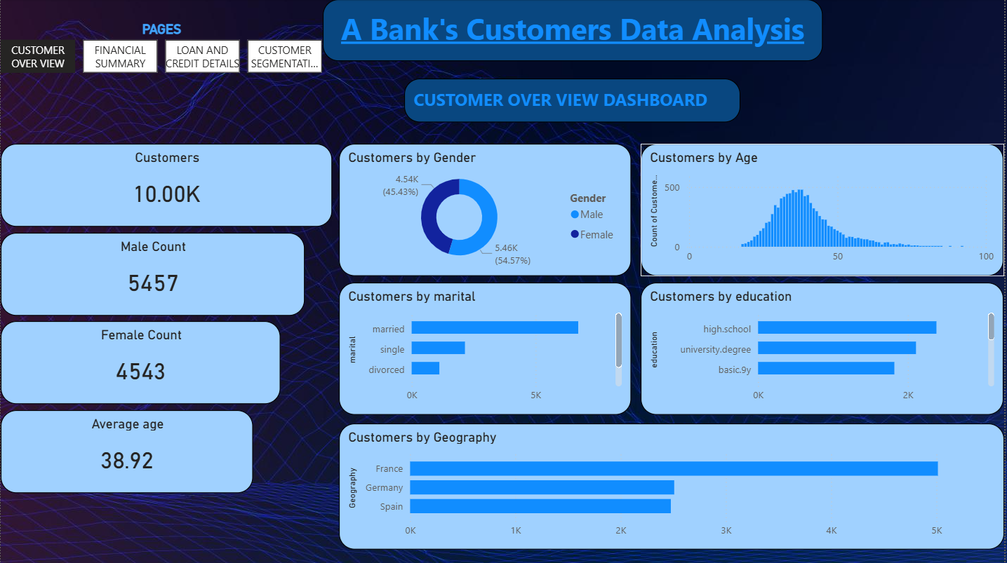
Visualizations Used
Visuals:
1. Card Visual – Total Customers
2. Card Visual – Male Count
3. Card Visual – Female Count
4. Card Visual – Average Age
5. Bar Chart – Customers by Geography
6. Bar Chart – Customers by Marital Status
7. Donut Chart / Pie Chart – Customers by Gender
8. Bar Chart – Customers by Education
9. Histogram / Area Chart – Customers by Age Distribution
Queries use in 1stpage (CUSTOMER OVER VIEW DASHBOARD):
Male count:
Male Count = CALCULATE(COUNTROWS('Bank Data'),'Bank Data'[Gender]="Male")
Female count:
Female Count = CALCULATE(COUNTROWS('Bank Data'),'Bank Data'[Gender]="Female")
Average age:
Average age = CALCULATE(AVERAGE('Bank Data'[Age]))

2. FINANCIAL SUMMARY DASHBOARD
This dashboard explains how customers manage their financial activities, including credit score, balance, and product usage.
• Credit Card Holders: 7,055
• Average Credit Score: 650.53
• Total Banking Products: 15,000
• Average Customer Balance: 76.49K
• Total Customer Balance: 764.86M
Financial Distribution:
• Balance by Geography: Spain has the highest balance.
• Credit Score by Tenure: Score changes based on customer years in bank.
• Products by Gender: Shows product usage by males and females.
• Balance by Age: Middle-aged customers have higher balances.
Screenshort of dashboard(FUNANCIAL SUMMARY):
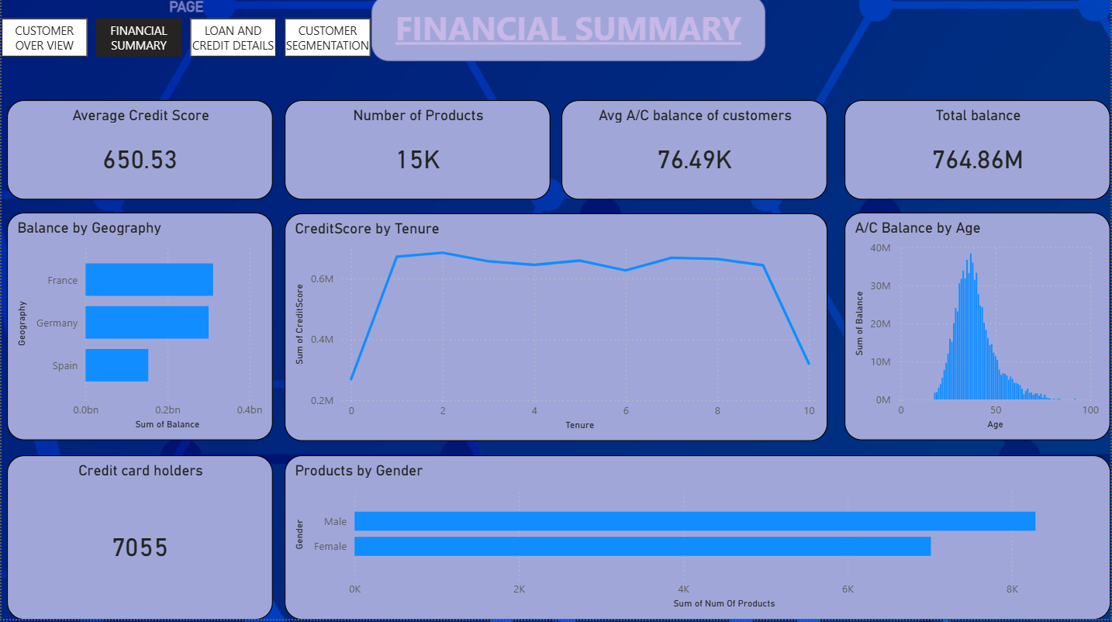
Visualizations Used
Visuals:
1. Card Visual – Total Credit Card Holders
2. Card Visual – Average Credit Score
3. Card Visual – Total Products
4. Card Visual – Average Account Balance
5. Card Visual – Total Balance
6. Bar Chart – Balance by Geography
7. Line Chart – Credit Score by Tenure
8. Bar Chart – Products by Gender
9. Histogram / Area Chart – Balance by Age
Queries use in 2nd page (FUNANCIAL SUMMARY) :
Average credit score:
Average credit score = CALCULATE(AVERAGE('Bank Data'[CreditScore]))
Average account Balance of customers:
Average account Balance of customers = CALCULATE(AVERAGE('Bank Data'[Balance]))

3. LOAN AND CREDIT DETAILS DASHBOARD
This dashboard provides information about loans taken by customers and their credit scores.
• Customers Having Loans: 8,262
• Customers Without Loans: 1,450
• Credit Card Holders: 7,055
Loan & Credit Distribution:
• Loan by Gender: Shows loan count for males and females.
• Loan by Education: Graduates take the most loans.
• Loan by Geography: Spain has the most loan customers.
• Loan by Tenure: Shows loans based on years with bank.
• Credit Score by Age: Older customers have better scores.
• High Credit Score (>900): 44 customers.
• Low Credit Score: 676 customers.
Screenshort of dashboard (LOAN AND CREDIT DETAILS):
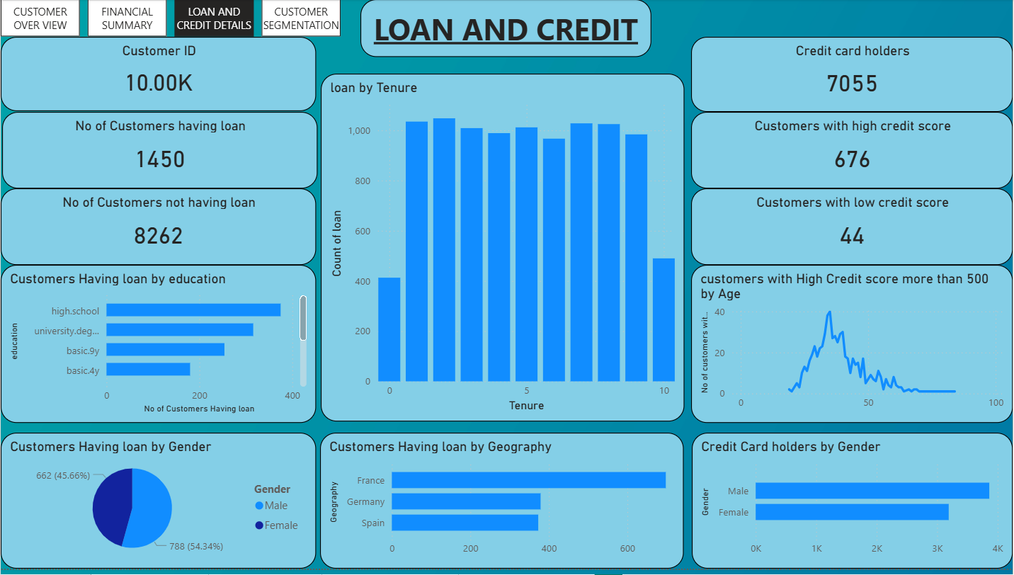
Visualizations Used
Visuals:

1. Card Visual – Customers Having Loans
2. Card Visual – Customers Not Having Loans
3. Card Visual – Credit Card Holders
4. Pie Chart – Loan Customers by Gender
5. Bar Chart – Customers Having Loan by Education
6. Bar Chart – Loan Customers by Geography
7. Bar Chart – Loan by Tenure
8. Line Chart – Credit Score by Age
9. Card Visual – High Credit Score Customers (>900)
10. Card Visual – Low Credit Score Customers

Queries use in 3rd page (LOAN AND CREDIT DETAILS) :
No of Customers Having loan:
No of Customers Having loan = CALCULATE(COUNTROWS('Bank Data'),'Bank Data'[loan]="Yes")
No of Customers not having loan:
No of Customers not having loan = CALCULATE(COUNTROWS('Bank Data'),'Bank Data'[loan]="No")
No of customers with High Credit score more than 500:
No of customers with High Credit score more than 500 = CALCULATE(COUNTROWS('Bank Data'),'Bank Data'[CreditScore] < 500)
No of customers with low Credit score less than 100:
No of customers with low Credit score less than 100 = CALCULATE(COUNTROWS('Bank Data'),'Bank Data'[CreditScore] < 100)

4. CUSTOMER SEGMENTATION DASHBOARD
This dashboard gives a simple summary of:
The overall distribution of customers based on age, balance, salary, and geography.
It helps identify which customers fall under young or elder groups.
It also shows customers with high balance, low balance, high salary, and low salary.
Additional Insights:
Customer Distribution

Age Segmentation: Shows the count of Young and Elder customers.
Balance Segmentation: Shows customers with High Balance and Low Balance.
Salary Segmentation: Shows High Salary and Low Salary customers.
Balance by Age: Shows how the account balance changes for different age groups.
High Salary by Age: Shows which age groups earn more salary.
Customers by Country: Shows customer count in Spain, France, and Germany.
Customer Table: Displays customer surname, age, balance, and estimated salary for detailed view.
Visualizations Used
Cards:
Young Customers,Elder Customers,High Balance Customers,Low Balance Customers,High Salary Customers,Low Salary Customers
Column Chart: Balance by Age
Line Chart / Area Chart: High Salary by Age
Pie / Donut Chart: Customers by Country
Table: Customer details (Surname, Age, Balance, Salary)
Screenshort of dashboard (CUSTOMER SEGMENTATION):
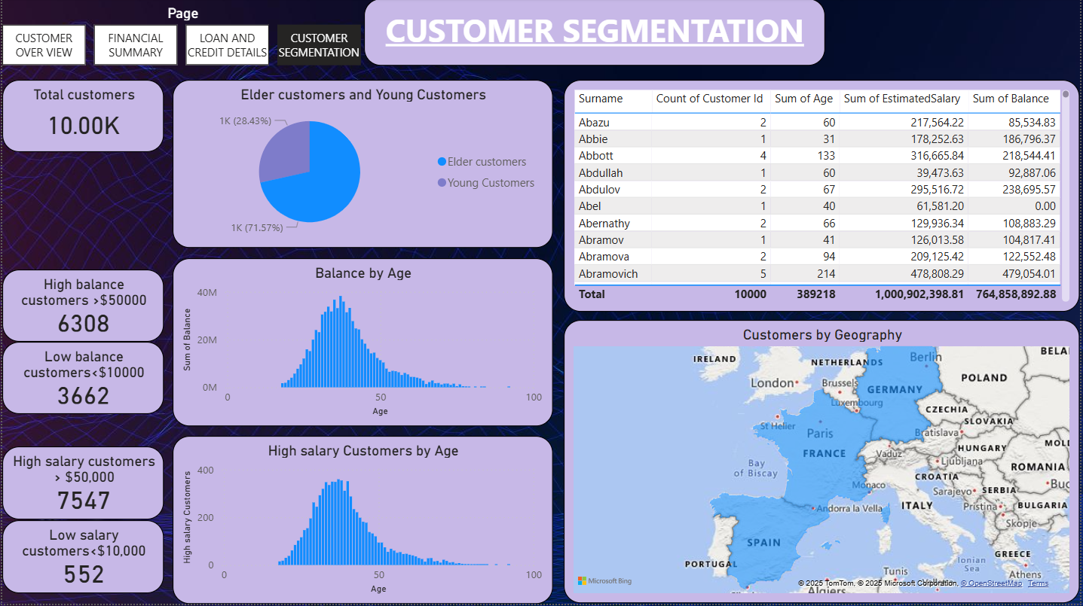
Queries use in 4TH page (CUSTOMER SEGMENTATION) :
High salary Customers:
High salary Customers = CALCULATE(COUNTROWS('Bank Data'),'Bank Data'[EstimatedSalary]>50000)
low salary customers:
low salary customers = CALCULATE(COUNTROWS('Bank Data'),'Bank Data'[EstimatedSalary]<10000)
High balance customers:
High balance customers = CALCULATE(COUNTROWS('Bank Data'),'Bank Data'[Balance]>50000)
Low balance customers:
Low balance customers = CALCULATE(COUNTROWS('Bank Data'),'Bank Data'[Balance]<10000)
Elder customers:
Elder customers = CALCULATE(COUNTROWS('Bank Data'),'Bank Data'[Age]>50)
Young Customers:
Young Customers = CALCULATE(COUNTROWS('Bank Data'),'Bank Data'[Age]<25)

Conclusion
These dashboards provide a complete understanding of customer demographics, financial health, loan behavior, and overall segmentation. The visuals help in making data-driven decisions for improving banking services and customer retention.

